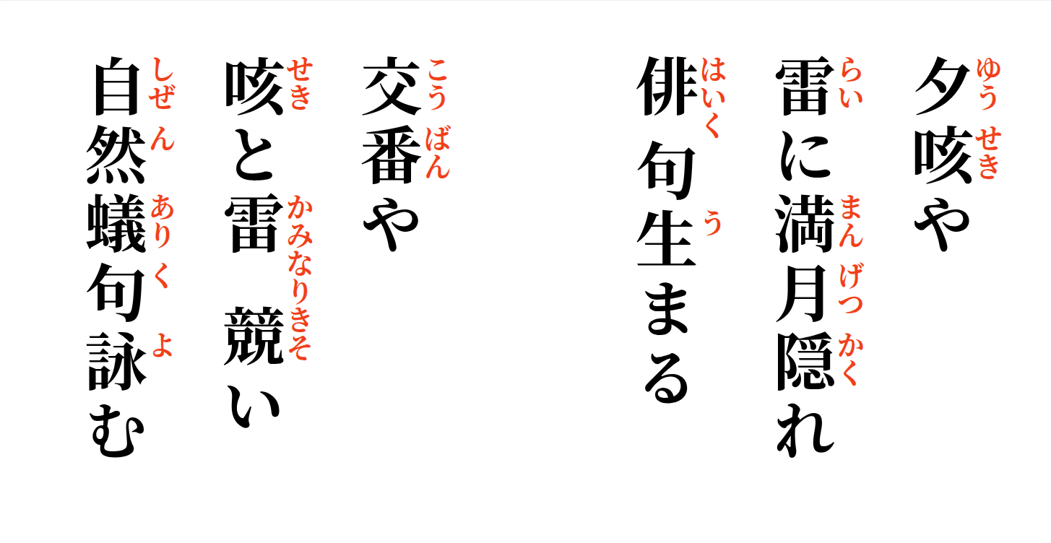

Evening coughing—
the full moon hides behind thunder;
a haiku is born.

By the police box,
cough and thunder contend—
nature recites Yoshinori's ant haiku.

